1. Jenkins server is installed and run on the port 8081.
2. Slave node has been created and run.

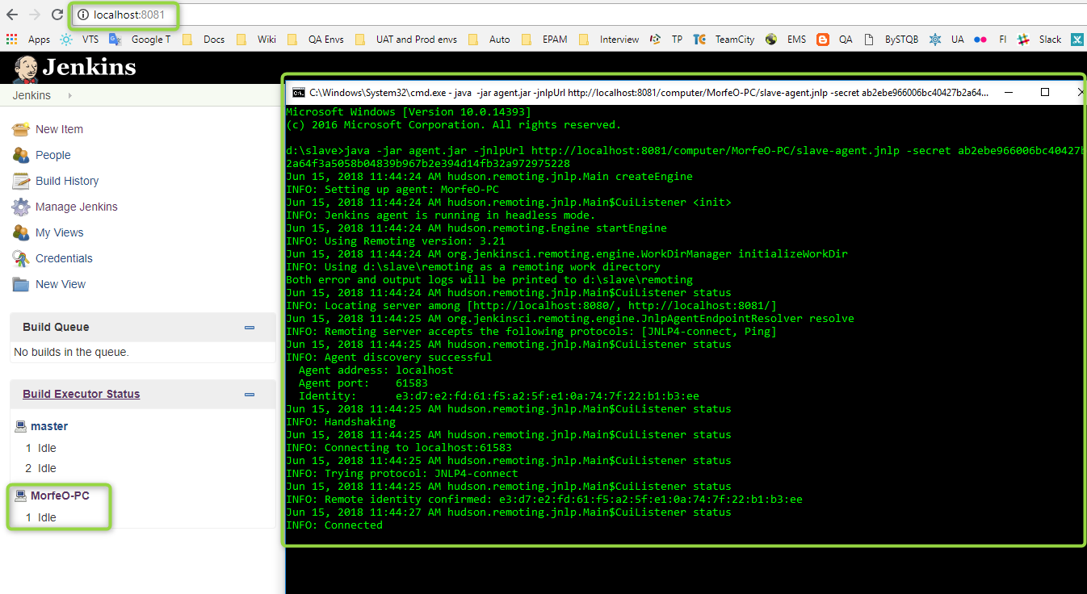

1. Job is configured for execution only on selected slave node, Git repository is used as the Source Code Management.

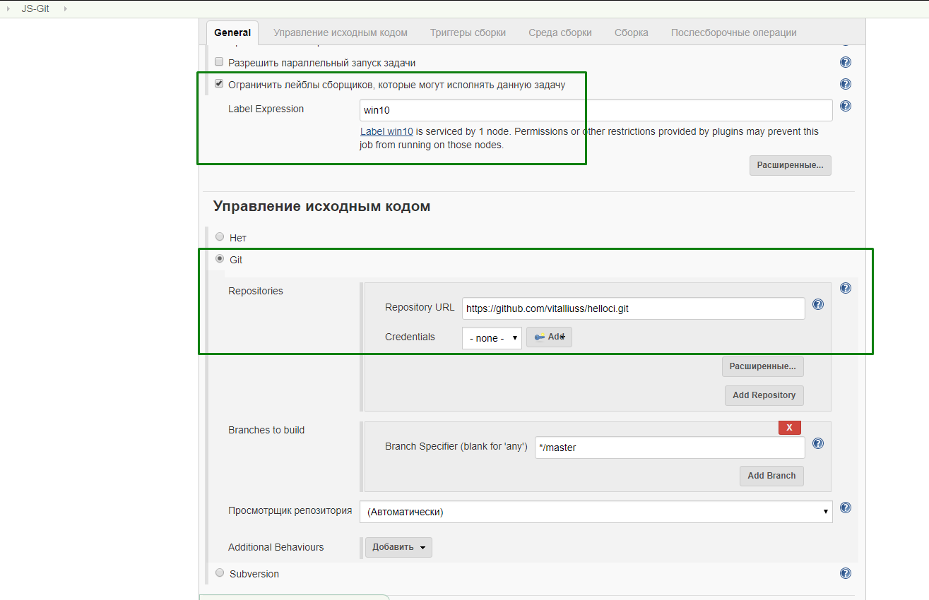

1. Build triggers are set: Build periodically (at midnight every day) and Poll SCM (after each commit no longer than in 5 minutes).

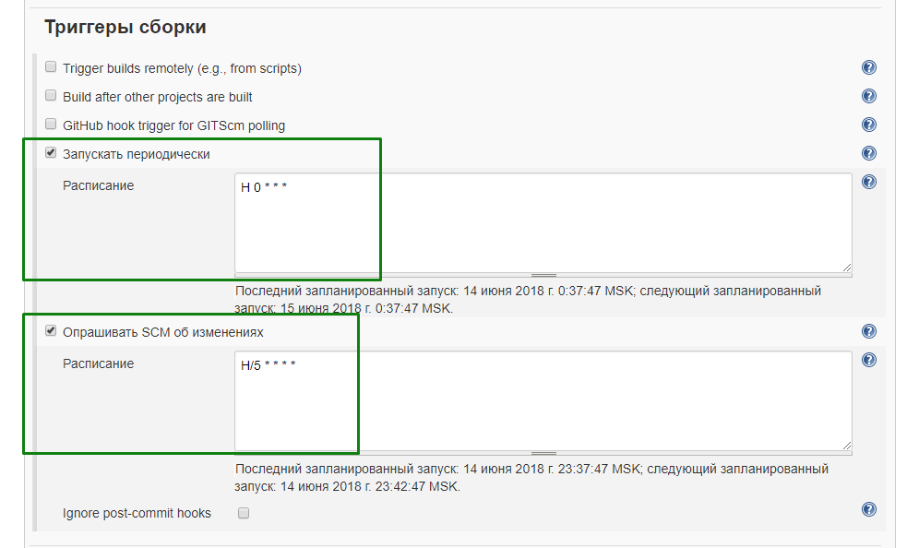

1. Added Build step to execute Windows batch command (execution js file via nodejs).

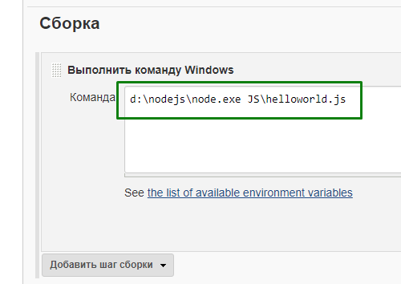

1. Job’s logs: run on slave machine, cloned the repository and executed js file.

